Biology Review #’s 1-25

1. Patterns of Diversity (well suited to the environment, diversified, same species didn’t live everywhere)

Living Organisms & Fossils (some disappeared and some survived)

Animals varied in predictable (Tortoises have short necks if their food was close to the ground & had long neck if food was high up)

1. Differently shaped beak
2. *On the Origin of Species*
3. Descent with modification from a common ancestor
4. Increase chance of survival
5. Legs on a skink, tailbone and appendix in humans, hind leg bones in a whale
6. Kingdom, Phylum, Class, Order, Family, Genus (1st name in binomial nomenclature) , Species (2nd name in binomial nomenclature)
7. Genus and Species
8. Animalia and Plantae
9. Kingdom
10. Cladistic analysis – identifies and considers only characteristics of organisms that are evolutionary innovations.

A cladogram is a diagram used to help show evolutionary relationships among a group of organisms

1. No random mating, no large populations, migration, mutations, natural selection
2. 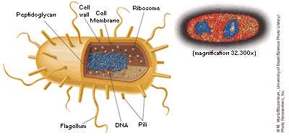
3. Single celled, no nucleus (prokaryotic), eubacterium have peptidoglycan while Archaebacteria lack it peptidoglycan, have different membrane lipids, and have DNA sequences more like eukaryotes

20. shapes, cells walls, movement

22. Recycle nutrients to maintain equilibrium in the environment. Ex: fungi, bacteria, some insects

1. DNA
2. 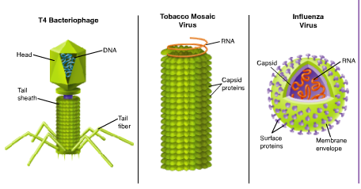
3. Composed of DNA or RNA with a protein coat
4. Viral capsid – uses proteins to bind to receptors on the surface of a cell and trick it into getting inside the membrane envelope
5. Lysogenic infection – remains inactive for a period of time,  virus integrates its DNA into the DNA of the host cell, and the viral genetic information replicates along with the host cell's DNA,

Lytic infection - a virus enters a cell, makes copies of itself, and causes the cell to burst.

1. Damage cells and tissues of infected organisms by breaking down cells for food

Release toxins that interfere with normal body activity

1. Disease – causing agents
2. Helper T-Cells
3. 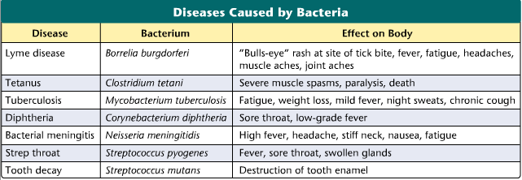

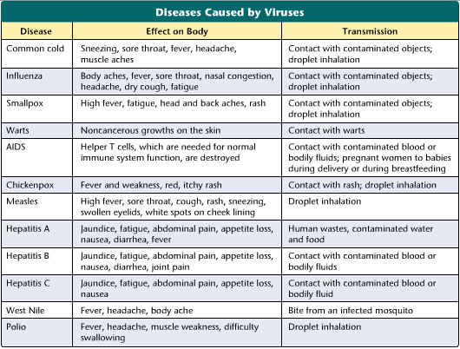

1. Eukaryotes, Uni or Multicellular, Kingdom Protista (not Plant, Animal, or fungi)
2. Movement. Ex: Zooflagellates, Pseudopods, Cilliates, Sporozoans

WGeo Review Unit 9 East Asia

1. High mountains in the Western part restrict movement and contact (Ex: Kunlun and Qinling Shandi Mts)
2. China (Qin D ynasty)
3. Electronic Industry
4. Huang He is a cultural hearth in East Asia, China’s conquering influence cultures, innovation, diffusion, acculturation
5. Irrigate crops, provide hydroelectric power and transportation
6. Japan, South Korea, Taiwan
7. Sun Yat-Sen founded the Nationalist party in 1912 because China wanted to form a republic. They were defeated by the Communist party and they moved to Taiwan.
8. They’re an economic tiger with a strong economy, cheap labor, lots of exporting, and they have advanced technology
9. Taiwan
10. Earthquakes and Volcanic eruptions
11. Original inhabitants were from the mainland of Asia. The Yamato clan ruled during the 5th century. A strong central government formed and the samurai was introduced during the Heian Period from 794 – 1185. Shoguns began to rule in 1192. After WW2 a constitutional monarchy formed.
12. Most ppl live on the coastal plains of Japan because the interior is mountainous
13. Japanese are protesting to end pollution, overcrowding, asking for shorter work days, and more vacation time.
14. Mt. Fiji
15. 1923: Japanese earthquake of Toktyou killed 140,000 ppl
16. 1853: Commodore Matthew Perry from U.S. ends isolation
17. It was a British colony of fishing and trade till it was given to China in 1997
18. Rapid economic growth with cheap labor, highly industrialized, high technology, trade with nations around the world, aggressive exports, very prosperous economies
19. Beijing, China

Ulaanbaatar, Mongolia

Seoul, South Korea

Tokyo, Japan

Pyongyang, North Korea

Taipei, Taiwan

1. Buddhism: Offshoot of Hinduism, develop in 536 B.C. in India near Nepal.

Founder: Siddhartha Gautama, Buddha, Enlightened One

Beliefs: rejected the Hindu idea of caste

Promotes correct way of living to reach the Spiritual state of Nirvana

Came to China from India and grew into an important religion in China in 300 A.D.

Influence by Confucianism and Taoism as it develop in China

Believes in rebirth and the End of the rebirth cycle

Eightfold Path: (this is a link that I found about it. Just put whatever info u think is most important to know) <http://buddhism.about.com/od/theeightfoldpath/a/eightfoldpath.htm>

1. Confucianism:

Founder: Chinese philosopher Confucius from 551 – 479 B.C.

Beliefs: respect the past and your elders

Importance of education and orderly society where kids obey parents and parents obey the government and emperor